**E-Governance In Healthcare E-Governance In Healthcare E-Governance In Healthcare E-Governance In Healthcare E-Governance In Healthcare E-Governance In Healthcare E-Governance In Healthcare E-Governance In Healthcare E-Governance In Healthcare E-Governance In Healthcare E-Governance In Healthcare E-Governance In Healthcare E-Governance Healthcare E-Governane In Healthcare E-Governance In Healthcare E-Governance In Healthcare E-Governance In Healthcare E-Governance In Healthcare E-Governance In Healthcare E-Governance In Healthcare E-Governance In Healthcare E-Governance In Healthcare E-Governance In Healthcare E-Governance In Healthcare E-Governance In Healthcare E-Governance In Healthcare E-Governance In Healthcare E-Governance In Healthcare E-Governance In Healthcare E-Governance In Healthcare E-Gov**

|  |
| --- |
| *E-Governance In Healthcare*  **A Project Report**  **Submitted to Asansol Engineering College in partial fulfilment of the requirements for the degree of**  **Bachelor of Technology**  **(Information Technology)**  **of**  **Maulana Abul Kalam AzadUniversity of Technology** |

*E-Governance In Healthcare*

**By**

**Munmun Sen (Roll No.: 10800212046)**

**Suvrajit Bhattacharjee(Roll No.:10800212082)**

**Soumi Majumder (Roll No.:10800212073)**

**Rashmita Karak(Roll No.:10800212064)**

**A Project Report**

**Submitted to Asansol Engineering College in partial fulfilment of the requirements for the degree of**

**Bachelor of Technology**

**(Information Technology)**

**of**

**Maulana Abul Kalam AzadUniversity of Technology**

**Under the guidance of**

**Mr. Debabrata Maity**

**(Asst. Professor)**



**Department of Information Technology**

**Asansol Engineering College**

**Asansol**

**2016**

CERTIFICATE FROM PROJECT GUIDE(S)

***This is to certify that the project entitled “E-Governance In Healthcare” submitted by* Munmun Sen (Roll No.: 10800212046), Suvrajit Bhattacharjee (Roll No.:10800212082), Soumi Majumder(Roll No.:10800212073), Rashmita Karak(Roll No.:10800212064) *, for the award of B. Tech. (Information Technology) degree of Maulana Abul Kalam Azad University of Technology is absolutely based upon their own work under the supervision of* Mr. Debabrata Maity (Asst. Professor) *, Department of Information Technology, Asansol Engineering College, Asansol, India and that neither their project report nor any part of the report has been submitted for any degree/diploma or any other academic award anywhere before.***



**Name and Designation of Project Guide:**

**____________________________**

**Mr. Debabrata Maity**

**(Asst. Professor)**

**Information Technology**

**Asansol Engineering College**

**Internal Examiner External Examiner**

**ACKNOWLEDGEMENT**

**We the final year student of 2016 batch of “ASANSOL ENGINEERING COLLEGE”, ”Information Technology” are presenting project on “*E-Governance In Healthcare*”. It was a great experience during the development of the project. It was a wonderful environment to work with all our group mates, their useful plans, suggestions and code contributions were highly appreciative.**

**We are thankful to Asansol Engineering College, for providing us a scope to develop a project.**

**We are grateful to the project guider Lecturer Asst. Prof. Debabrata Maiti for guiding us in this project. We got help in all possible ways whether it is theoretical or practical to successfully complete the project from our guide. He also told us the importance and application of the project. Without him, our knowledge would not have flourished enough to complete the project. Last but not the least we are also thankful to our laboratory guide Mr. Amitava Roy for providing us all the software and internet facility for this project and also for providing us a great environment to work and executes our project.**

**Munmun Sen**

**Suvrajit Bhattacharjee**

**Soumi Majumder**

**Rashmita Karak**

### CONTENTS

**Chapters Pages**

**1. Project Synopsis 5**

**2. Introduction 6**

**3. Project Details 8**

**3.1. System Requirements 8**

**3.2. Definitions and Theories 9**

**3.3. Entity Relationship Diagram 19**

**3.4. Tables 20**

**3.5. Line Of Code 23**

**3.6. Data Flow Diagram 58**

**3.7. Results 60**

**4. Screen Shots 61**

**5. Conclusion and Future Scope 81**

**6. Bibliography 82**

**-----X-----**

***1.PROJECT SYNOPSIS***

***As India is one of the fastest developing countries in the world, it is important to improve the quality of our health maintenance management and preventive medical care to extend healthy life expectancy. Today’s scenario for health care in Indian egovernance is in the limit of contacting 75 hospitals of the ISRO Telemedicine network only. Whilst this is currently working best of it, the limitation of this can be retarded by introducing the health care web services to each individual of the country. We believe advanced implementation of Information and Communications Technologies (ICT) may improve the medical services and health maintenance management. As medical science is fast developing and information resource is pouring in, there is urgent need for dissemination knowledge by interlinking primary, secondary and tertiary level health centers by ICT applications. This will help health personal to deliver high quality services. Moreover, IT systems have been built to support different work flows in the health sector, but the systems are rarely connected and have become islands of data. From 2006 onwards corporate IT giants are experimenting for ICT  
application in health sector both in Government and private hospitals. In this paper, we discuss the potentialities and expansibility of the XML Web Services based on the Adaptive Collaboration (AC) which can be aggregated by the Indian e governance system as a health care web services. We would like to present ways of improving health maintenance service and regional medical services. In order to realize better health maintenance and prevention of disease, we would like to prove that incorporating medicine, life, and work through the XML Web Services is highly effective.***

*2.Introduction*

This standard sets out the requirements for documentation and management for all models of health care records within the National Public Health System. Health care records promote patient safety, continuity of care across time and care settings, and support the transfer of information when the care of a patient / client is transferred eg. at clinical handover, during escalation of care for a deteriorating patient and transfer of a patient / client between settings.

**Privacy and confidentiality**

**All information in a patient / client’s health care record is confidential and subject to prevailing privacy laws and policies. Health care records contain health information which is protected under legislation. The requirements of the legislation, including the Privacy Principles, are explained in plain English in the Health Privacy Manual.3 Health care personnel should only access a health care record and use or disclose information contained in the record when it is directly related to their duties and is essential for the fulfilment of those duties, or as provided for under relevant legislation.**

***Auditing***

***Health care records across all settings and clinical areas must be audited for compliance with this policy. PHOs must establish a framework and schedule for auditing of records and approve and designate audit tools and processes.***

*3.* ***PROJECT DETAILS***

***3.1 Software Requirements Specifications:***

**OPERATING SYSTEM : WINDOWS 8**

**DATA BASE : SQL**

**SOFTWARE : VISUAL STUDIO 12**

**FRONT END TOOL : VISUAL STUDIO 12**

**LANGUAGE : ASP.NET**

**SCRIPTING LANGUAGE : C#**

**WEB COMPONENTS : ASP**

***3.2 Definitions and theories***

***The frequency of documentation entries should conform to the following as minimum requirements.***

***1. Acute Care Patient / clients***

***a) Registered Nurse / Midwife, Enrolled / Endorsed Nurse should make an entry in the  
patient / client’s health care record a minimum of once a shift. An entry by an Assistant in  
Nursing should not be the only entry for a shift. Entries should reflect in a timely way the level of assessment and intervention. The results of significant diagnostic investigations and significant changes to the patient / client’s condition and/or treatment should be documented as these occur.  
b) Medical practitioners should make an entry in the health care record at the time of events,  
or as soon as possible afterwards, including when reviewing the patient / client.  
c) Other health care personnel should make entries to reflect their level of assessment and  
intervention consistent with the medical management plan.***

* ***Long Stay or Residential Patients / Clients:***

***Depending on the health care setting and the length of stay (or expected length of stay) of the  
patient / client, health care personnel should make an entry at least weekly in the health care  
record particularly when warranted by the patient’s medical condition or frailty.  
Additional entries should be made to reflect changes in the patient / client status, condition and/or  
treatment or care plan as these occur.***

***3. Non-Admitted Patient / Clients:***

***An entry must be made in the health care record for each patient / client attendance (including  
video conference sessions) and for failures to attend. Entries should reflect the level of assessment and intervention. The results of significant diagnostic investigations and significant changes to the patient / client’s condition and/or treatment should be documented. Attendance of individual patient / clients at sessions of a formal multiple session group program should be noted. Such attendances may be documented in an attendance register or scheduling system rather than the patient / client’s health care record. Where a patient / client receives specific individual care or treatment in addition to the group session interaction, this care or treatment should be documented in their health care record.***

***4. Alerts and allergies:***

***Clinicians must flag issues that require particular attention or pose a threat to the patient / client,  
staff or others including:  
a) Allergies / sensitivities or adverse reactions, and the known consequence.  
b) Infection prevention and control risks.  
c) Behaviour issues that may pose a risk to themselves or others.  
d) Child protection / well being matters including  
i. alerts and flags for High Risk Birth Alerts or prenatal reports  
ii. children at risk of significant harm  
iii. where NSW Police or the Department of Family and Community Services have  
issued a general alert to a PHO.  
e) Where patients / clients have similar names and other demographic details.  
PHOs must implement systems for the identification of such alerts and allergies. If a label is used  
on the outside folder of a paper based health care record this does not negate the need for  
documentation in the health care record of the alert / allergy, and known consequence.  
Any such issue should be ‘flagged’ or recorded conspicuously on appropriate forms, screens or  
locations within the health care record. Where alerts relate to behaviour issues or child protection  
matters the alert should be discreet to ensure the privacy and safety of the patient / client, staff or  
others.  
These flags, especially where codes or abbreviations are used, must be apparent to and easily  
understood by health care personnel; must not be ambiguous; and should be standardised within  
the PHO.***

***5. Tests – requests and results:***

***The health care record must document pathology, radiology and other tests ordered, the  
indication and the result.  
When tests are ordered the name of the ordering medical practitioner / approved clinician and  
their contact number must be clearly printed (if written) or entered (if computerised) on the  
request form.  
Pathology, radiology and other test results must be followed up and reviewed with notation as to  
action required. The results must be endorsed by the receiving medical practitioner / approved  
clinician, with endorsement involving the name, signature, designation of the medical practitioner  
/ approved clinician, and date / time.  
PHOs must develop local procedures, including steps to be taken, when:  
a) Relevant details on the request form are incomplete or illegible.  
b) The ordering medical practitioner / approved clinician is not on duty or contactable.***

***Critical/unexpected/abnormal results should be documented in the patient / client’s health care  
record by the responsible medical practitioner / approved clinician as soon as practicable and any  
resultant change in care / treatment plans documented.***

***6. Patient / client clinical incidents:***

***All actual clinical incidents must be documented in the patient / client’s health care record.8  
Staff must document in the health care record.  
a) Incident Information Management System (IIMS) identification number.  
b) Clinically relevant information about the incident.  
c) Interactions related to open disclosure processes.***

***7. Complaints :***

***Complaint records are not to be kept with the patient’s health care record.***

***8. Emergency Department records:***

***Emergency Department records must include the following:***

***a) Date and time triaged including triage score.  
b) Presenting problem and triage assessment.  
c) Date and time seen by a medical practitioner, other clinicians such as a Clinical Initiatives  
Nurse, Nurse Practitioner, nursing, midwifery and allied health staff.  
d) Medical, nursing, midwifery and allied health assessment.  
e) Pathology, radiology and other tests ordered. Pathology, radiology and other test results  
must be followed up and reviewed with notation as to action required.  
f) Description of critical / unexpected / abnormal pathology, radiology and other test results.  
If the patient / client has left the Emergency Department and not been admitted, document  
the steps taken to contact the patient / client or their carer if the test results indicate that  
urgent treatment / care is required.  
g) Details of treatment.  
h) Follow up treatment where applicable.  
i) Transfer of care date and time, destination (eg. home, other level of health care) method  
and whether accompanied.***

* ***Operation / procedure reports:  
  Operation / procedure reports must include the following:  
  a) Date of operation / procedure.  
  b) Pre-operative and post-operative diagnosis.  
  c) Indication for operation / procedure.  
  d) Procedure safety checklist.  
  e) Surgical operation / procedure performed.  
  f) Personnel involved in performing the operation / procedure.  
  g) Outline of the method of surgery / procedure.  
  h) Product / device inserted and batch number.***
* ***Telephone / electronic consultation with patient / clients :  
  When clinical information is provided to a patient / client, or their care-taker / guardian / advocate, the consultation must be documented in the health care record. The identification of the caller must be documented.  
  Where the caller is not the patient / client, or their care-taker / guardian / advocate obtain consent from the patient / client, or their care-taker / guardian / advocate prior to the consultation. Document the  
  a) Caller’s name,  
  b) Relationship to the patient / client, and   
  c) That the patient / client, or their care-taker / guardian / advocate has consented to the caller  
  seeking clinical information about the patient / client in the patient / client’s health care record.***
* ***Leave taken by patients / clients :  
  Any leave taken by the patient / client should be documented in their health care record with the date / time the patient / client left and returned. The patient / client should be assessed before proceeding on leave and the outcome of that assessment documented in the health care record, together with the documented approval of the AMP noting the assessment.***

***MANAGEMENT******1. Responsibility and accountability:***

***The Chief Executive of the PHO must comply with the State Records Act and its regulation in respect of health care records. Responsibility for the maintenance of appropriate health care records must be included in the terms and conditions of appointment (including position descriptions) for all health care personnel as defined in this policy. Documentation must be included as a standing item in annual performance reviews of clinicians. Failure to maintain adequate health care records will be managed in accordance with current NSW Health policies and guidelines for managing potential misconduct.***

***2. Individual health care record :******An individual health care record with a unique identifier (eg unique patient identifier, medical record number) must be created for each patient / client who receives health care. Every live or still born baby must be allocated a unique identifier that is different to the mother. Where multiple patient identifiers exist for the same patient / client within a PHO there must be processes established for their reconciliation and linkage, with the ability to audit those processes. A reference notation should be placed on the health care record to identify any relevant other documents that relate to the patient’s health care. Index or patient administration systems must reference the existence of satellite / decentralised health care records that address a specific issue and that are kept separate from the principal health care record. Due to the nature of the information contained in sexual assault records these must be maintained separately from the principal health care record and be kept secure at all times; as should child protection / well being and genetics records. Staff screening and vaccination records are considered as personnel rather than health care records and must be maintained separately.***

***3. Access :***

***Health care records should be available at the point of care or service delivery. Health care records must not be removed from the campus unless prior arrangements have been made with the PHO eg. required for a home visit, required under subpoena.***

***Health care records are only accessible to:  
a) Health care personnel currently providing care / treatment to the patient / client.  
b) Staff involved in patient safety, the investigation of complaints, audit activities or research (subject to ethics committee approval, as required).  
c) Staff involved in urgent public health investigations for protecting public/population health, consistent with relevant legislation.***

***d) Patient / client to whom the r****ecord relates, or their authoriz****ed agent, based on a case by case basis in accordance with health service release of information policies and privacy laws.******e) Other personn****el / organiz****ations / individuals in accordance with a court subpoena, statutory authority, valid search warrant, coronial summons****, or other lawful order authoriz****ed by legislation, common law or NSW Health policy.  
All requests for information, that is contained in a patient / client’s health care record, from a third / external party should be handled by appropriately qualified and experienced health care personnel, such as Health Information Managers, due to the sensitive nature of health care records; the special terminology used within them; and regulatory requirements around access to, and disclosure of, information.***

***4. Storage and security :***

***The Health Records and Information Privacy Act 2002 establishes statutory requirements for the storage and security of health care records, which are also included in the NSW Health Privacy Manual. A summary of these requirements is provided below. However, the Privacy Manual should be consulted for further detail in this area. Personal health information, including healthcare records, must have appropriate security safeguard****s in place to prevent unauthoriz****ed use, disclosure, loss or other misuse. For example, all records containing personal health information should be kept in lockable storage or secure access areas when not in use.***

***5. Disposal :***

***Health care records, both paper based and electronic, must be disposed of in a manner that will preserve the privacy and confidentiality of any information they contain. Disposal of data records should be done in such as way as to render them unreadable and leave them in a form from which they cannot be reconstructed in whole or in part. Paper records containing personal health information should be disposed of by shredding, pulping or burning. Where large volumes of paper are involved, specialised services for the safe disposal of confidential material should be employed. The disposal of health care records must be documented in the PHO’s Patient Administration System and undertaken in accordance with the relevant State General Disposal Authority.***

**3.3. Entity Relationship Diagram**

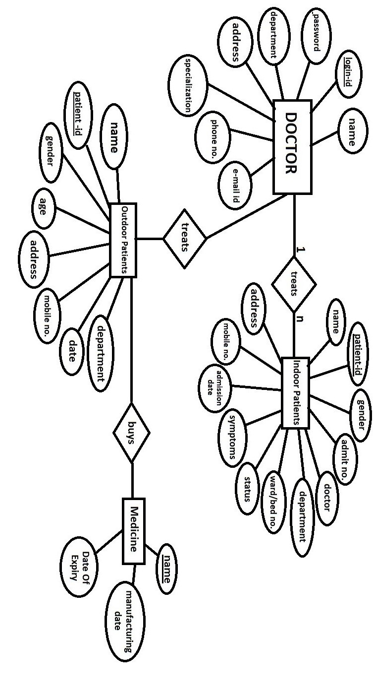

**3. data Tables used in the website**

**Table 1:** doctorsignup

**Attribute Type**

|  |  |
| --- | --- |
| **name** | **varchar(20)** |
| **loginid** | **varchar(20),primary key** |
| **password** | **varchar(20)** |
| **department** | **varchar(20)** |
| **specialization** | **varchar(20)** |
| **phonenumber** | **int** |
| **address** | **varchar(20)** |
| **email** | **varchar(20)** |

**Table 2: hospital_patientinfo**

**Attributes Type**

|  |  |
| --- | --- |
| **patientid** | **int, PRIMARY KEY** |
| **patientname** | **varchar(20)** |
| **age** | **varchar(20)** |
| **department** | **varchar(20)** |
| **doctor** | **varchar(20)** |

**Table 3: hospital_outpatient**

**Attributes Type**

|  |  |
| --- | --- |
| **patientname** | **varchar(20)** |
| **patientid** | int, PRIMARY KEY |
| **gender** | varchar(20) |
| **age** | int |
| **address** | varchar(20) |
| **mobileno** | int |
| **date** | datetime |
| **department** | varchar(20) |

**Table 4 : inpatient**

**Attributes Type**

|  |  |
| --- | --- |
| **patientname** | **varchar(20)** |
| **patientid** | int, PRIMARY KEY |
| **gender** | varchar(20) |
| **address** | varchar(20) |
| **mobileno** | big int |
| **admdate** | int |
| **admit** | int |
| **status** | varchar(20) |
| **symptoms** | varchar(20) |
| **department** | varchar(20) |
| **wardbedno** | varchar(20) |
| **doctor** | varchar(20) |

**3.5 Line of code**

**main.aspx.cs**

**using System;**

**using System.Collections.Generic;**

**using System.Linq;**

**using System.Web;**

**using System.Web.UI;**

**using System.Web.UI.WebControls;**

**public partial class main : System.Web.UI.Page**

**{**

**protected void Page_Load(object sender, EventArgs e)**

**{**

**}**

**protected void Button1_Click(object sender, EventArgs e)**

**{**

**Response.Redirect("home.aspx");**

**}**

**}**

**appointment.aspx.cs**

**using System;**

**using System.Data;**

**using System.Configuration;**

**using System.Collections;**

**using System.Web;**

**using System.Web.Security;**

**using System.Web.UI;**

**using System.Web.UI.WebControls;**

**using System.Web.UI.WebControls.WebParts;**

**using System.Web.UI.HtmlControls;**

**using System.Data.SqlClient;**

**public partial class appointment : System.Web.UI.Page**

**{**

**SqlConnection con = new SqlConnection("Data Source=MOON;Initial Catalog=Ehealth;Integrated Security=True");**

**SqlCommand com=new SqlCommand();**

**string dt = DateTime.Now.ToShortDateString();**

**protected void Page_Load(object sender, EventArgs e)**

**{**

**TextBox6.Text = dt;**

**}**

**protected void Button2_Click(object sender, EventArgs e)**

**{**

**Response.Redirect("reception.aspx");**

**}**

**protected void Button1_Click(object sender, EventArgs e)**

**{**

**con.Open();**

**com = new SqlCommand("insert into patientinfo1 values('" + DropDownList2.SelectedItem.Value + "','" + DropDownList3.SelectedItem.Value + "','" + TextBox2.Text + "','" + TextBox3.Text + "','" + TextBox4.Text + "','" + TextBox5.Text + "','" + TextBox6.Text + "')", con);**

**com.ExecuteNonQuery();**

**con.Close();**

**Response.Redirect("reception.aspx");**

**}**

**protected void DropDownList2_SelectedIndexChanged(object sender, EventArgs e)**

**{**

**con.Open();**

**if (DropDownList2.Text == "In-Patient")**

**{**

**string qry = "select patientid from inpatient1";**

**SqlDataAdapter da = new SqlDataAdapter(qry, con);**

**DataSet ds = new DataSet();**

**da.Fill(ds, "inpatient1");**

**DropDownList3.DataSource = ds;**

**DropDownList3.DataTextField = "patientid";**

**DropDownList3.DataBind();**

**DropDownList3.Items.Insert(0, "...Select...");**

**}**

**else if (DropDownList2.SelectedItem.Value == "Out-Patient")**

**{**

**string qry = "select patientid from outpatient1";**

**SqlDataAdapter da = new SqlDataAdapter(qry, con);**

**DataSet ds = new DataSet();**

**da.Fill(ds, "outpatient1");**

**DropDownList3.DataSource = ds;**

**DropDownList3.DataTextField = "patientid";**

**DropDownList3.DataBind();**

**DropDownList3.Items.Insert(0, "...Select...");**

**}**

**else if (DropDownList2.SelectedItem.Value == "...Select...")**

**{**

**Response.Redirect("reception.aspx");**

**}**

**con.Close();**

**}**

**protected void DropDownList3_SelectedIndexChanged(object sender, EventArgs e)**

**{**

**if (DropDownList2.SelectedItem.Value == "In-Patient")**

**{**

**con.Open();**

**com = new SqlCommand("select patientname,age,department,doctor from inpatient1 WHERE patientid ='" + DropDownList3.SelectedValue + "'", con);**

**SqlDataReader dr = com.ExecuteReader();**

**if (dr.Read())**

**{**

**TextBox2.Text = dr[0].ToString();**

**TextBox3.Text = dr[1].ToString();**

**TextBox4.Text = dr[2].ToString();**

**TextBox5.Text = dr[3].ToString();**

**dr.Close();**

**con.Close();**

**}**

**}**

**else if (DropDownList2.SelectedItem.Value == "Out-Patient")**

**{**

**con.Open();**

**com = new SqlCommand("select patientname,age,department,doctor from outpatient1 WHERE patientid ='" + DropDownList3.SelectedValue + "'", con);**

**SqlDataReader dr = com.ExecuteReader();**

**if (dr.Read())**

**{**

**TextBox2.Text = dr[0].ToString();**

**TextBox3.Text = dr[1].ToString();**

**TextBox4.Text = dr[2].ToString();**

**TextBox5.Text = dr[3].ToString();**

**}**

**dr.Close();**

**con.Close();**

**}**

**}**

**}**

**Dischargereport.aspx.cs**

**using System;**

**using System.Data;**

**using System.Configuration;**

**using System.Collections;**

**using System.Web;**

**using System.Web.Security;**

**using System.Web.UI;**

**using System.Web.UI.WebControls;**

**using System.Web.UI.WebControls.WebParts;**

**using System.Web.UI.HtmlControls;**

**using System.Data.SqlClient;**

**public partial class Dischargesummary : System.Web.UI.Page**

**{**

**SqlConnection cn = new SqlConnection("Data Source=MOON;Initial Catalog=Ehealth;Integrated Security=True");**

**protected void Page_Load(object sender, EventArgs e)**

**{**

**}**

**protected void Calendar1_SelectionChanged(object sender, EventArgs e)**

**{**

**TextBox3.Text = Calendar1.SelectedDate.ToShortDateString();**

**Calendar1.Visible = false;**

**}**

**protected void DropDownList1_SelectedIndexChanged(object sender, EventArgs e)**

**{**

**cn.Open();**

**SqlCommand Cmd = new SqlCommand("select patientname,admdate from inpatient1 WHERE patientid ='" + DropDownList1.SelectedValue + "'", cn);**

**SqlDataReader dr = Cmd.ExecuteReader();**

**if (dr.Read())**

**{**

**TextBox1.Text = dr[0].ToString();**

**TextBox2.Text = dr[1].ToString();**

**}**

**dr.Close();**

**cn.Close();**

**}**

**protected void Button1_Click(object sender, EventArgs e)**

**{**

**cn.Open();**

**SqlCommand cmd = new SqlCommand("insert into dischargereport values('" + DropDownList1.SelectedItem.Value + "','" + TextBox1.Text + "','" + TextBox2.Text + "','" + TextBox3.Text + "')", cn);**

**cmd.ExecuteNonQuery();**

**cn.Close();**

**Response.Redirect("Summaryreport");**

**}**

**protected void Button2_Click(object sender, EventArgs e)**

**{**

**Response.Redirect("Summaryreport");**

**}**

**protected void Button3_Click(object sender, EventArgs e)**

**{**

**Calendar1.Visible = true;**

**}**

**}**

**doctorlogin.aspx.cs**

**using System;**

**using System.Data;**

**using System.Configuration;**

**using System.Collections;**

**using System.Web;**

**using System.Web.Security;**

**using System.Web.UI;**

**using System.Web.UI.WebControls;**

**using System.Web.UI.WebControls.WebParts;**

**using System.Web.UI.HtmlControls;**

**using System.Data.SqlClient;**

**public partial class Login : System.Web.UI.Page**

**{**

**SqlConnection con = new SqlConnection();**

**SqlDataReader dr;**

**protected void Page_Load(object sender, EventArgs e)**

**{**

**con.ConnectionString = "Data Source=MOON;Initial Catalog=Ehealth;Integrated Security=True";**

**}**

**protected void Button1_Click1(object sender, EventArgs e)**

**{**

**con.Open();**

**string qry;**

**qry = "select * from doctorsignup where loginid='" + idtext.Text + "' and password='" + pwtext.Text + "'";**

**SqlCommand cmd = new SqlCommand(qry, con);**

**dr = cmd.ExecuteReader();**

**if (dr.Read())**

**{**

**Response.Redirect("doctorchamber.aspx");**

**}**

**else**

**{**

**pwlbl.Text = "Enter valid UserName/Password";**

**}**

**con.Close();**

**}**

**protected void Button2_Click(object sender, EventArgs e)**

**{**

**Response.Redirect("doctorsignup.aspx");**

**}**

**}**

**doctorsignup.aspx.cs**

**using System;**

**using System.Data;**

**using System.Configuration;**

**using System.Collections;**

**using System.Web;**

**using System.Web.Security;**

**using System.Web.UI;**

**using System.Web.UI.WebControls;**

**using System.Web.UI.WebControls.WebParts;**

**using System.Web.UI.HtmlControls;**

**using System.Data.SqlClient;**

**public partial class doctorsignup : System.Web.UI.Page**

**{**

**SqlConnection con= new SqlConnection();**

**SqlCommand com;**

**protected void Page_Load(object sender, EventArgs e)**

**{**

**con.ConnectionString = "Data Source=MOON;Initial Catalog=Ehealth;Integrated Security=True";**

**}**

**protected void Button1_Click(object sender, EventArgs e)**

**{**

**con.Open();**

**com = new SqlCommand("insert into doctorsignup values('" + TextBox1.Text + "','" + TextBox2.Text + "','" + TextBox3.Text + "','" + TextBox4.Text + "','" + DropDownList1.SelectedItem.Value + "','" + DropDownList2.SelectedItem.Value + "','" + TextBox5.Text + "','" + TextBox6.Text + "')", con);**

**com.ExecuteNonQuery();**

**con.Close();**

**Response.Redirect("doctorlogin.aspx");**

**}**

**protected void Button2_Click(object sender, EventArgs e)**

**{**

**Response.Redirect("doctorsignup.aspx");**

**}**

**protected void Button3_Click(object sender, EventArgs e)**

**{**

**Response.Redirect("home.aspx");**

**} }**

**indoorpatient.aspx.cs**

**using System;**

**using System.Data;**

**using System.Configuration;**

**using System.Collections;**

**using System.Web;**

**using System.Web.Security;**

**using System.Web.UI;**

**using System.Web.UI.WebControls;**

**using System.Web.UI.WebControls.WebParts;**

**using System.Web.UI.HtmlControls;**

**using System.Data.SqlClient;**

**public partial class indoorpatient : System.Web.UI.Page**

**{**

**SqlConnection cn = new SqlConnection("Data Source=MOON;Initial Catalog=Ehealth;Integrated Security=True");**

**SqlCommand cmd;**

**protected void Page_Load(object sender, EventArgs e)**

**{**

**if (!Page.IsPostBack)**

**{**

**filldrop();**

**DropDownList5.Items.Insert(0, "...Select...");**

**}**

**string dt = DateTime.Now.ToShortDateString();**

**TextBox7.Text = dt;**

**}**

**void filldrop()**

**{**

**cn.Open();**

**string qry = "select name from doctorsignup";**

**SqlDataAdapter da = new SqlDataAdapter(qry, cn);**

**DataSet ds = new DataSet();**

**da.Fill(ds, "doctorsignup");**

**DropDownList5.DataSource = ds;**

**DropDownList5.DataTextField = "name";**

**DropDownList5.DataBind();**

**cn.Close();**

**}**

**protected void Button1_Click(object sender, EventArgs e)**

**{**

**cn.Open();**

**cmd = new SqlCommand("insert into inpatient1 values('" + TextBox1.Text + "','" + TextBox2.Text + "','" + DropDownList1.SelectedItem.Value + "','" + TextBox3.Text + "','" + TextBox4.Text + "','" + TextBox5.Text + "','" + DropDownList2.SelectedItem.Value + "','" + TextBox6.Text + "','" + TextBox7.Text + "','" + DropDownList3.SelectedItem.Value + "','" + TextBox8.Text + "','" + DropDownList4.SelectedItem.Value + "','" + DropDownList5.SelectedItem.Value + "','" + TextBox9.Text + "')", cn);**

**cmd.ExecuteNonQuery();**

**cn.Close();**

**Response.Redirect("doctorchamber.aspx");**

**}**

**protected void Button2_Click(object sender, EventArgs e)**

**{**

**Response.Redirect("indoorpatient.aspx");**

**}**

**}**

**MasterPage.master**

**<%@ Master Language="C#" AutoEventWireup="true" CodeFile="MasterPage.master.cs" Inherits="MasterPage" %>**

**<!DOCTYPE html>**

**<html xmlns="http://www.w3.org/1999/xhtml">**

**<head runat="server">**

**<title></title>**

**<asp:ContentPlaceHolder id="head" runat="server">**

**</asp:ContentPlaceHolder>**

**</head>**

**<body>**

**<div>**

**<form id="form1" runat="server">**

**<div>**

**<br />**

**<br />**

**<br />**

**<br />**

**<br />**

**<br />**

**<br />**

**<br />**

**<br />**

**<br />**

**<br />**

**<br />**

**<br />**

**&nbsp;&nbsp;&nbsp;&nbsp;&nbsp;&nbsp;&nbsp;&nbsp;&nbsp;&nbsp;**

**<asp:Image ID="Image1" runat="server" ImageUrl="~/pics/e-Hospital-A-Digital-India-Programme-Initiative-Making-Healthcare-Easy-and-Transparent1 (1).jpg"**

**Style="z-index: 100; left: 18px; position: absolute; top: -23px; height: 694px; width: 902px;" />**

**<br />**

**<br />**

**<br />**

**<br />**

**<br />**

**<asp:ContentPlaceHolder ID="ContentPlaceHolder1" runat="server">**

**</asp:ContentPlaceHolder>**

**</div>**

**</form>**

**</body>**

**</html>**

**outdoorpatient.aspx.cs**

**using System;**

**using System.Data;**

**using System.Configuration;**

**using System.Collections;**

**using System.Web;**

**using System.Web.Security;**

**using System.Web.UI;**

**using System.Web.UI.WebControls;**

**using System.Web.UI.WebControls.WebParts;**

**using System.Web.UI.HtmlControls;**

**using System.Data.SqlClient;**

**public partial class outdoorpatient : System.Web.UI.Page**

**{**

**SqlConnection con = new SqlConnection("Data Source=MOON;Initial Catalog=Ehealth;Integrated Security=True");**

**SqlCommand com;**

**string dt = DateTime.Now.ToShortDateString();**

**protected void Page_Load(object sender, EventArgs e)**

**{**

**TextBox6.Text = dt;**

**if (!Page.IsPostBack)**

**{**

**filldrop();**

**DropDownList3.Items.Insert(0, "...Select...");**

**}**

**}**

**void filldrop()**

**{**

**con.Open();**

**string qry = "select name from doctorsignup";**

**SqlDataAdapter da = new SqlDataAdapter(qry, con);**

**DataSet ds = new DataSet();**

**da.Fill(ds, "doctorsignup");**

**DropDownList3.DataSource = ds;**

**DropDownList3.DataTextField = "name";**

**DropDownList3.DataBind();**

**con.Close();**

**}**

**protected void Button1_Click(object sender, EventArgs e)**

**{**

**con.Open();**

**com = new SqlCommand("insert into outpatient1 values('" + TextBox1.Text + "','" + TextBox2.Text + "','" + TextBox3.Text + "','" + DropDownList1.SelectedItem.Value + "','" + TextBox4.Text + "','" + TextBox5.Text + "','" + TextBox6.Text + "','" + DropDownList2.SelectedItem.Value + "','" + DropDownList3.SelectedItem.Value + "')", con);**

**com.ExecuteNonQuery();**

**con.Close();**

**Response.Redirect("appointment.aspx");**

**}**

**protected void Button2_Click(object sender, EventArgs e)**

**{**

**Response.Redirect("patientregistration.aspx");**

**}**

**}**

**patientinfo.aspx.cs**

**using System;**

**using System.Collections.Generic;**

**using System.Linq;**

**using System.Web;**

**using System.Web.UI;**

**using System.Web.UI.WebControls;**

**using System.Web.Security;**

**using System.Web.UI.WebControls.WebParts;**

**using System.Web.UI.HtmlControls;**

**using System.Data.SqlClient;**

**using System.Data;**

**public partial class Patient_Info : System.Web.UI.Page**

**{**

**SqlConnection cn = new SqlConnection("Data Source=MOON;Initial Catalog=Ehealth;Integrated Security=True");**

**protected void Page_Load(object sender, EventArgs e)**

**{**

**}**

**else**

**{**

**SqlDataAdapter Da = new SqlDataAdapter("select * from outpatient1 where patientid='" + DropDownList2.SelectedValue + "'", cn);**

**DataSet Ds1 = new DataSet();**

**Da.Fill(Ds1, "outpatient1");**

**GridView1.DataSource = Ds1.Tables[0];**

**GridView1.DataBind();**

**}**

**cn.Close();**

**}**

**protected void Button1_Click(object sender, EventArgs e)**

**{**

**Response.Redirect("doctorchamber.aspx");**

**}**

**protected void GridView1_SelectedIndexChanged(object sender, EventArgs e)**

**{**

**}**

**protected void DropDownList1_SelectedIndexChanged(object sender, EventArgs e)**

**{**

**cn.Open();**

**if (DropDownList1.Text == "In-Patient")**

**{**

**string qry = "select patientid from inpatient1";**

**SqlDataAdapter da = new SqlDataAdapter(qry, cn);**

**DataSet ds = new DataSet();**

**da.Fill(ds, "inpatient1");**

**DropDownList2.DataSource = ds;**

**DropDownList2.DataTextField = "patientid";**

**DropDownList2.DataBind();**

**DropDownList2.Items.Insert(0, "...Select...");**

**}**

**else if (DropDownList1.SelectedItem.Value == "Out-Patient")**

**{**

**string qry = "select patientid from outpatient1";**

**SqlDataAdapter da = new SqlDataAdapter(qry, cn);**

**DataSet ds = new DataSet();**

**da.Fill(ds, "outpatient1");**

**DropDownList2.DataSource = ds;**

**DropDownList2.DataTextField = "patientid";**

**DropDownList2.DataBind();**

**DropDownList2.Items.Insert(0, "...Select...");**

**}**

**else if (DropDownList1.SelectedItem.Value == "...Select...")**

**{**

**Response.Redirect("patientinfo.aspx");**

**}**

**cn.Close();**

**}**

**}**

**pharmacy.aspx.cs**

**using System;**

**using System.Data;**

**using System.Configuration;**

**using System.Collections;**

**using System.Web;**

**using System.Web.Security;**

**using System.Web.UI;**

**using System.Web.UI.WebControls;**

**using System.Web.UI.WebControls.WebParts;**

**using System.Web.UI.HtmlControls;**

**using System.Data.SqlClient;**

**public partial class pharmacy : System.Web.UI.Page**

**{**

**SqlConnection cn = new SqlConnection("Data Source=MOON;Initial Catalog=Ehealth;Integrated Security=True");**

**SqlCommand cmd = new SqlCommand();**

**protected void Page_Load(object sender, EventArgs e)**

**{**

**}**

**protected void Button1_Click(object sender, EventArgs e)**

**{**

**cn.Open();**

**cmd = new SqlCommand("insert into pharmacy values('" + DropDownList1.SelectedItem.Value + "','" + DropDownList2.SelectedItem.Value + "','" + TextBox1.Text + "','" + TextBox2.Text + "','" + TextBox3.Text + "')", cn);**

**cmd.ExecuteNonQuery();**

**cn.Close();**

**Response.Redirect("reception.aspx");**

**}**

**protected void Button2_Click(object sender, EventArgs e)**

**{**

**Response.Redirect("pharmacy.aspx");**

**}**

**protected void DropDownList1_SelectedIndexChanged(object sender, EventArgs e)**

**{**

**cn.Open();**

**if (DropDownList1.Text == "In-Patient")**

**{**

**string qry = "select patientid from inpatient1";**

**SqlDataAdapter da = new SqlDataAdapter(qry, cn);**

**DataSet ds = new DataSet();**

**da.Fill(ds, "inpatient1");**

**DropDownList2.DataSource = ds;**

**DropDownList2.DataTextField = "patientid";**

**DropDownList2.DataBind();**

**DropDownList2.Items.Insert(0, "...Select...");**

**}**

**else if (DropDownList1.SelectedItem.Value == "Out-Patient")**

**{**

**string qry = "select patientid from outpatient1";**

**SqlDataAdapter da = new SqlDataAdapter(qry, cn);**

**DataSet ds = new DataSet();**

**da.Fill(ds, "outpatient1");**

**DropDownList2.DataSource = ds;**

**DropDownList2.DataTextField = "patientid";**

**DropDownList2.DataBind();**

**DropDownList2.Items.Insert(0, "...Select...");**

**}**

**else if (DropDownList1.SelectedItem.Value == "...Select...")**

**{**

**Response.Redirect("pharmacy.aspx");**

**}**

**cn.Close();**

**}**

**protected void DropDownList2_SelectedIndexChanged(object sender, EventArgs e)**

**{**

**if (DropDownList1.Text == "In-Patient")**

**{**

**cn.Open();**

**SqlCommand Cmd = new SqlCommand("select department,patientname from inpatient1 WHERE patientid ='" + DropDownList2.SelectedValue + "'", cn);**

**SqlDataReader dr = Cmd.ExecuteReader();**

**if (dr.Read())**

**{**

**TextBox1.Text = dr[0].ToString();**

**TextBox2.Text = dr[1].ToString();**

**}**

**dr.Close();**

**cn.Close();**

**}**

**else if (DropDownList1.SelectedItem.Value == "Out-Patient")**

**{**

**cn.Open();**

**SqlCommand Cmd = new SqlCommand("select department,patientname from outpatient1 WHERE patientid ='" + DropDownList2.SelectedValue + "'", cn);**

**SqlDataReader dr = Cmd.ExecuteReader();**

**if (dr.Read())**

**{**

**TextBox1.Text = dr[0].ToString();**

**TextBox2.Text = dr[1].ToString();**

**}**

**dr.Close();**

**cn.Close();**

**}**

**}**

**}**

**summaryreport.aspx.cs**

**using System;**

**using System.Data;**

**using System.Configuration;**

**using System.Collections;**

**using System.Web;**

**using System.Web.Security;**

**using System.Web.UI;**

**using System.Web.UI.WebControls;**

**using System.Web.UI.WebControls.WebParts;**

**using System.Web.UI.HtmlControls;**

**using System.Data.SqlClient;**

**public partial class Summaryreport : System.Web.UI.Page**

**{**

**SqlConnection cn = new SqlConnection("Data Source=MOON;Initial Catalog=Ehealth;Integrated Security=True");**

**protected void Page_Load(object sender, EventArgs e)**

**{**

**}**

**protected void Button1_Click(object sender, EventArgs e)**

**{**

**cn.Open();**

**string qry = "select * from dischargereport";**

**SqlDataAdapter da = new SqlDataAdapter(qry, cn);**

**DataSet ds = new DataSet();**

**da.Fill(ds);**

**GridView1.DataSource = ds;**

**GridView1.DataBind();**

**cn.Close();**

**}**

**}**

**surgeries.aspx.cs**

**using System;**

**using System.Data;**

**using System.Configuration;**

**using System.Collections;**

**using System.Web;**

**using System.Web.Security;**

**using System.Web.UI;**

**using System.Web.UI.WebControls;**

**using System.Web.UI.WebControls.WebParts;**

**using System.Web.UI.HtmlControls;**

**using System.Data.SqlClient;**

**public partial class surgeries : System.Web.UI.Page**

**{**

**SqlConnection cn = new SqlConnection("Data Source=MOON;Initial Catalog=Ehealth;Integrated Security=True");**

**protected void Page_Load(object sender, EventArgs e)**

**{**

**if (!Page.IsPostBack)**

**{**

**filldrop();**

**DropDownList1.Items.Insert(0, "...Select...");**

**}**

**}**

**void filldrop()**

**{**

**cn.Open();**

**string qry;**

**qry = "select patientid from inpatient1";**

**SqlDataAdapter da = new SqlDataAdapter(qry, cn);**

**DataSet ds = new DataSet();**

**da.Fill(ds, "inpatient1");**

**DropDownList1.DataSource = ds;**

**DropDownList1.DataTextField = "patientid";**

**DropDownList1.DataBind();**

**cn.Close();**

**}**

**protected void Calendar1_SelectionChanged(object sender, EventArgs e)**

**{**

**TextBox3.Text = Calendar1.SelectedDate.ToShortDateString();**

**}**

**protected void Button1_Click(object sender, EventArgs e)**

**{**

**cn.Open();**

**SqlCommand cmd = new SqlCommand();**

**cmd = new SqlCommand("insert into surgeryinfo values('" + DropDownList1.SelectedItem.Value + "','" + TextBox1.Text + "','" + TextBox2.Text + "','" + TextBox3.Text + "','" + TextBox4.Text + "','" + TextBox5.Text + "')", cn);**

**cmd.ExecuteNonQuery();**

**cn.Close();**

**Response.Redirect("reception.aspx");**

**}**

**protected void Button2_Click(object sender, EventArgs e)**

**{**

**Response.Redirect("reception.aspx");**

**}**

**protected void DropDownList1_SelectedIndexChanged(object sender, EventArgs e)**

**{**

**cn.Open();**

**SqlCommand cmd = new SqlCommand();**

**cmd = new SqlCommand("select patientname,age,department,doctor from inpatient1 WHERE patientid ='" + DropDownList1.SelectedValue + "'", cn);**

**SqlDataReader dr = cmd.ExecuteReader();**

**if (dr.Read())**

**{**

**TextBox1.Text = dr[0].ToString();**

**TextBox2.Text = dr[1].ToString();**

**TextBox4.Text = dr[2].ToString();**

**TextBox5.Text = dr[3].ToString();**

**dr.Close();**

**cn.Close();**

**}**

**}**

**protected void Button3_Click(object sender, EventArgs e)**

**{**

**Response.Redirect("surgeryreport.aspx");**

**}**

**}**

**surgeryreprt.aspx.cs**

**using System;**

**using System.Data;**

**using System.Configuration;**

**using System.Collections;**

**using System.Web;**

**using System.Web.Security;**

**using System.Web.UI;**

**using System.Web.UI.WebControls;**

**using System.Web.UI.WebControls.WebParts;**

**using System.Web.UI.HtmlControls;**

**using System.Data.SqlClient;**

**public partial class surgery : System.Web.UI.Page**

**{**

**SqlConnection cn = new SqlConnection("Data Source=MOON;Initial Catalog=Ehealth;Integrated Security=True");**

**protected void Page_Load(object sender, EventArgs e)**

**{**

**}**

**protected void Button1_Click(object sender, EventArgs e)**

**{**

**cn.Open();**

**string qry = "select * from surgeryinfo";**

**SqlDataAdapter da = new SqlDataAdapter(qry, cn);**

**DataSet ds = new DataSet();**

**da.Fill(ds);**

**GridView1.DataSource = ds;**

**GridView1.DataBind();**

**cn.Close();**

**}**

**}**

**viewappointment.aspx.cs**

**using System;**

**using System.Data;**

**using System.Configuration;**

**using System.Collections;**

**using System.Web;**

**using System.Web.Security;**

**using System.Web.UI;**

**using System.Web.UI.WebControls;**

**using System.Web.UI.WebControls.WebParts;**

**using System.Web.UI.HtmlControls;**

**using System.Data.SqlClient;**

**public partial class viewappointment : System.Web.UI.Page**

**{**

**SqlConnection cn = new SqlConnection("Data Source=MOON;Initial Catalog=Ehealth;Integrated Security=True");**

**protected void Page_Load(object sender, EventArgs e)**

**{**

**if (!Page.IsPostBack)**

**{**

**filldrop();**

**DropDownList1.Items.Insert(0, "...Select...");**

**}**

**}**

**void filldrop()**

**{**

**cn.Open();**

**string qry = "select name from doctorsignup";**

**SqlDataAdapter da = new SqlDataAdapter(qry, cn);**

**DataSet ds = new DataSet();**

**da.Fill(ds, "doctorsignup");**

**DropDownList1.DataSource = ds;**

**DropDownList1.DataTextField = "name";**

**DropDownList1.DataBind();**

**cn.Close();**

**}**

**protected void Button1_Click(object sender, EventArgs e)**

**{**

**cn.Open();**

**string qry = "select * from patientinfo1 where doctor='" + DropDownList1.SelectedValue + "' ";**

**SqlDataAdapter da = new SqlDataAdapter(qry, cn);**

**DataSet ds = new DataSet();**

**da.Fill(ds);**

**GridView1.DataSource = ds;**

**GridView1.DataBind();**

**cn.Close();**

**}**

**protected void DropDownList1_SelectedIndexChanged(object sender, EventArgs e)**

**{**

**}**

**protected void Button2_Click(object sender, EventArgs e)**

**{**

**Response.Redirect("doctorchamber.aspx");**

**}**

**}**

**3.6. Data Flow Diagram**

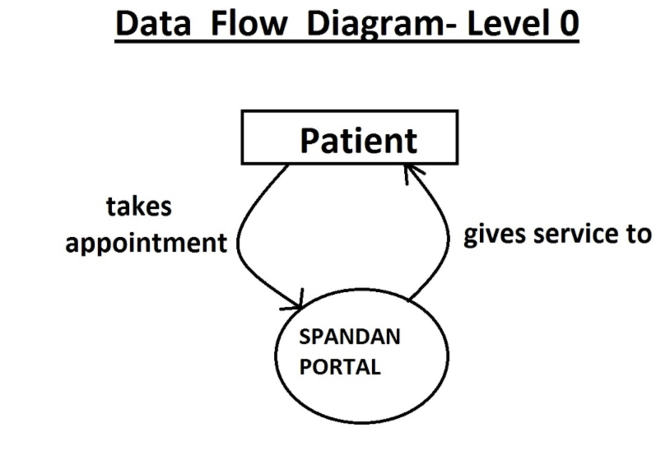

**Data Flow Diagram- level 1**

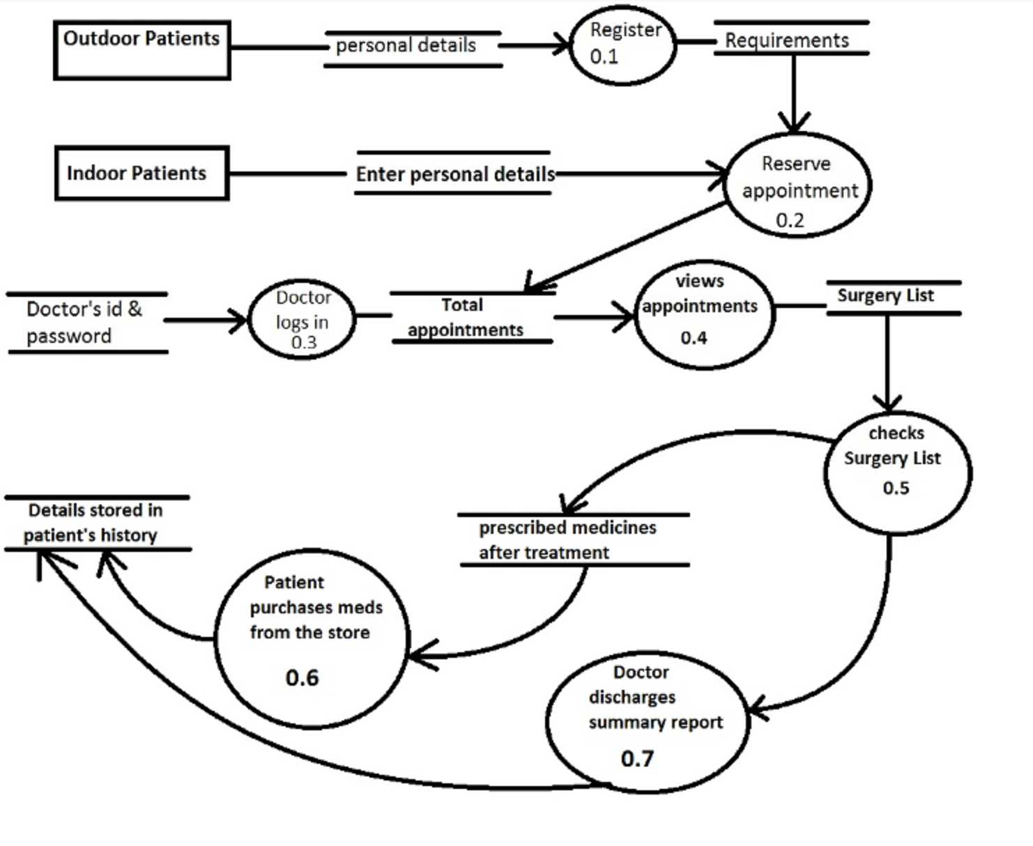

**Results**

**Thus from this project we have been able to use the applications of asp.net in creating a useful website for the online hospital management. There are many ways that this portal can be used and through this service not only can patients be treated and kept in record easily, but the huge population of young people can get jobs easily since they are quite acquainted with the working system of the software technology. Moreover this project makes the entire system time-saving and more efficient.**

**Screenshots**

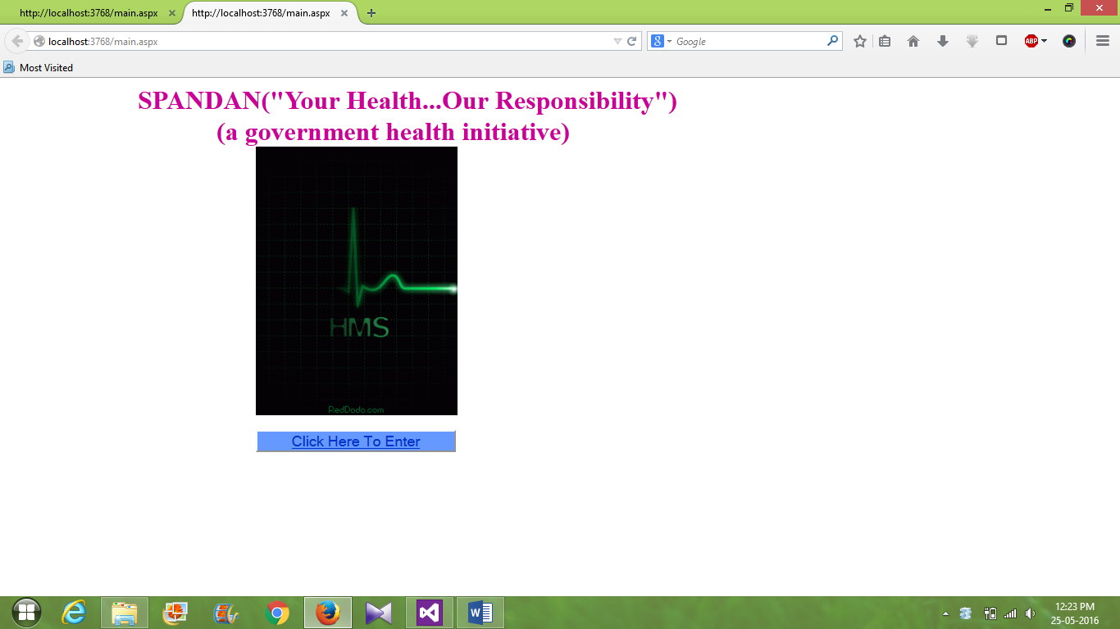

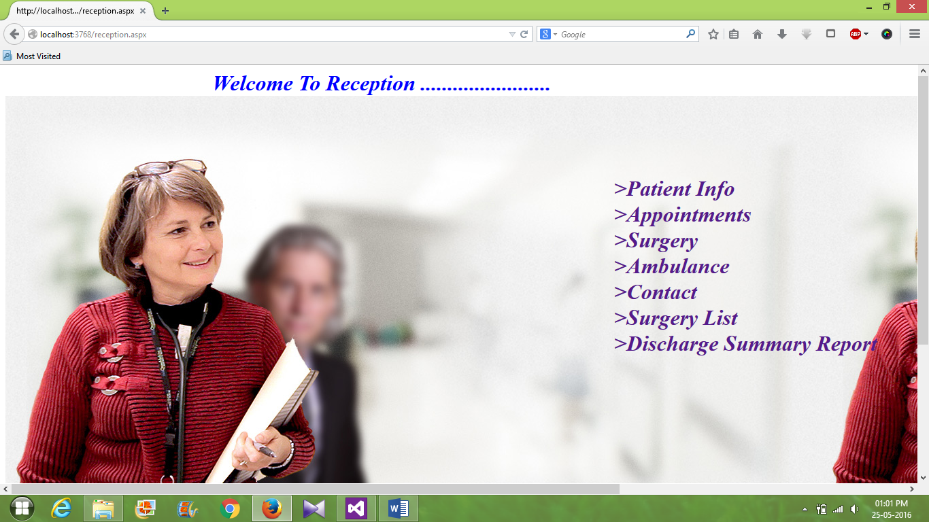

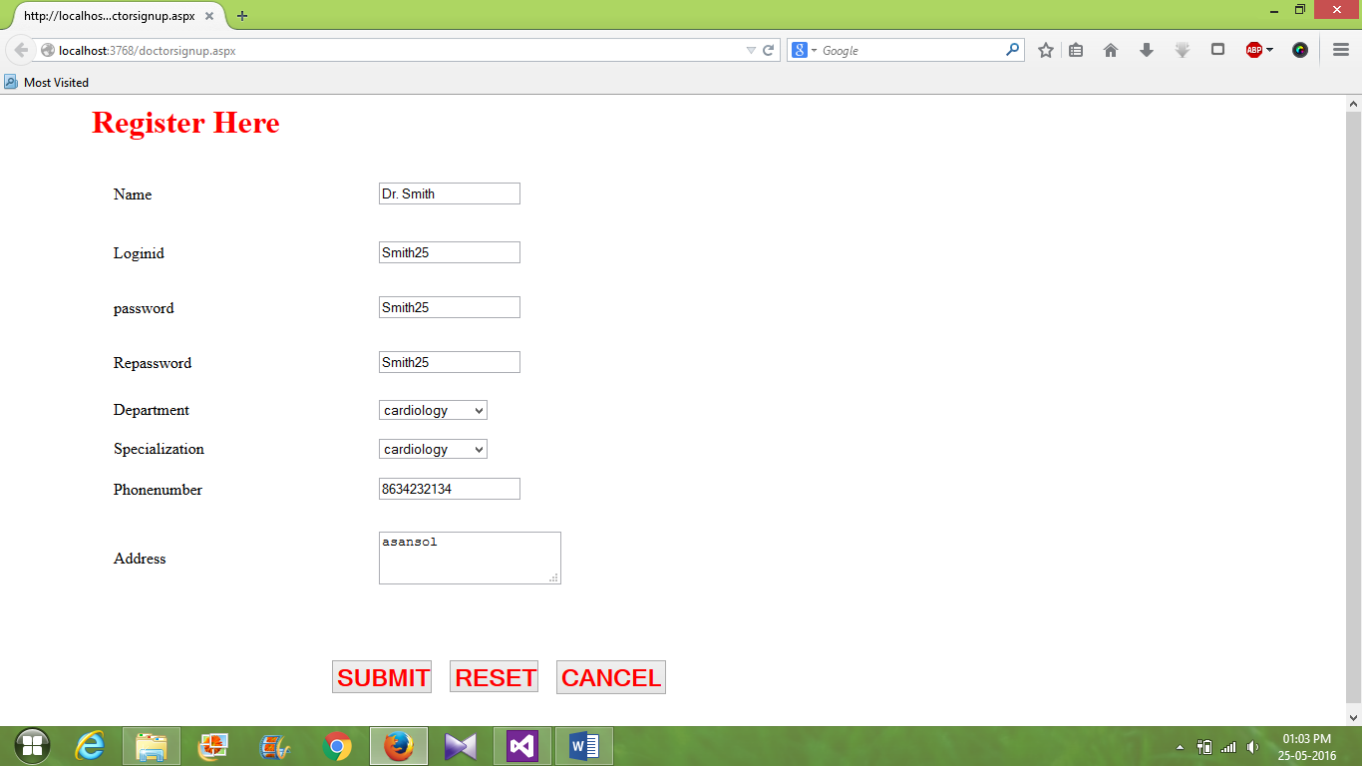

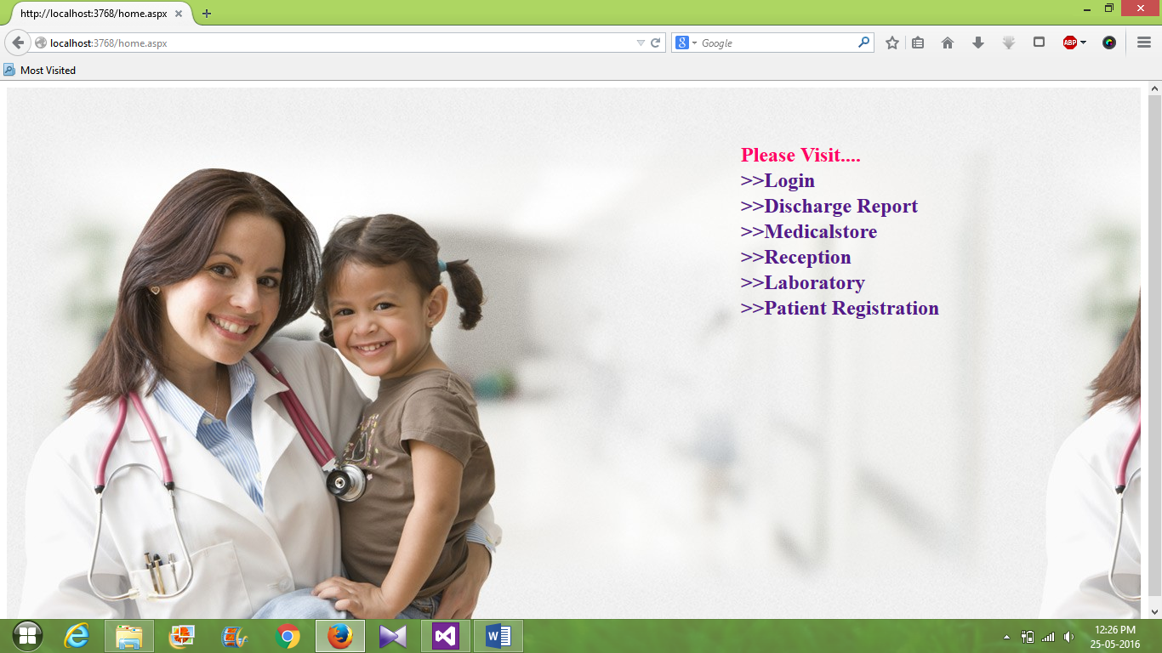

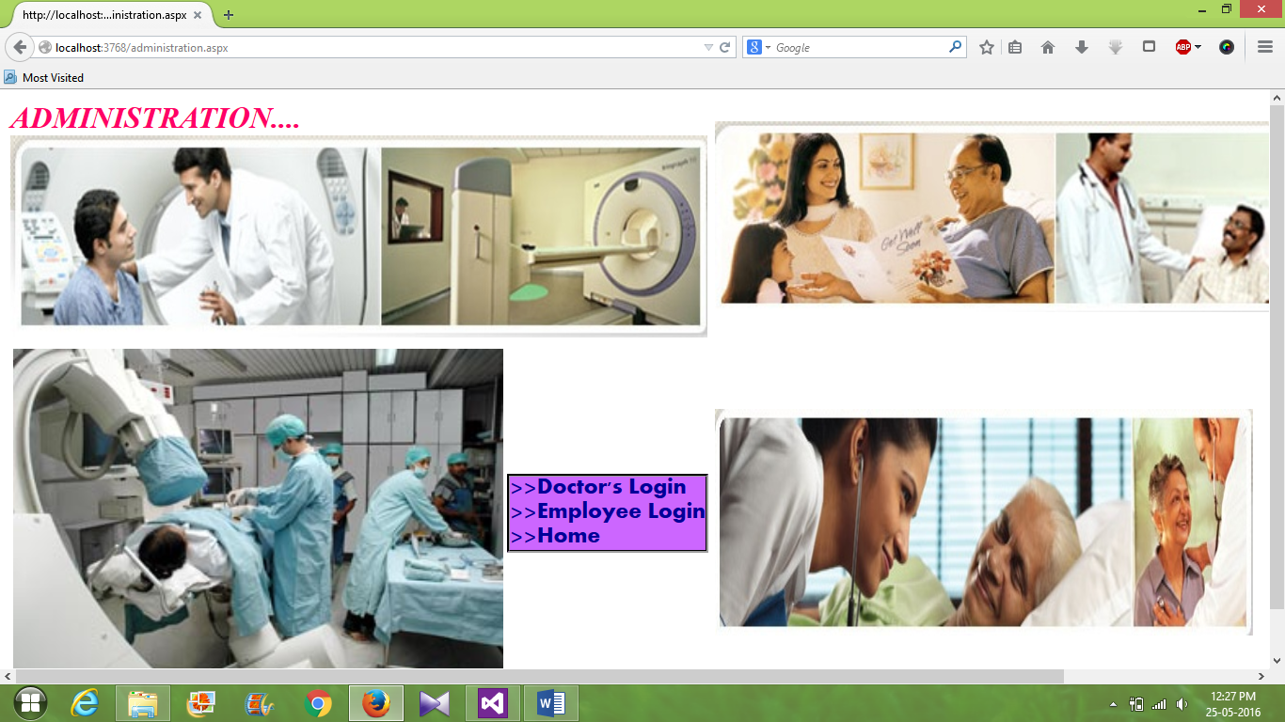



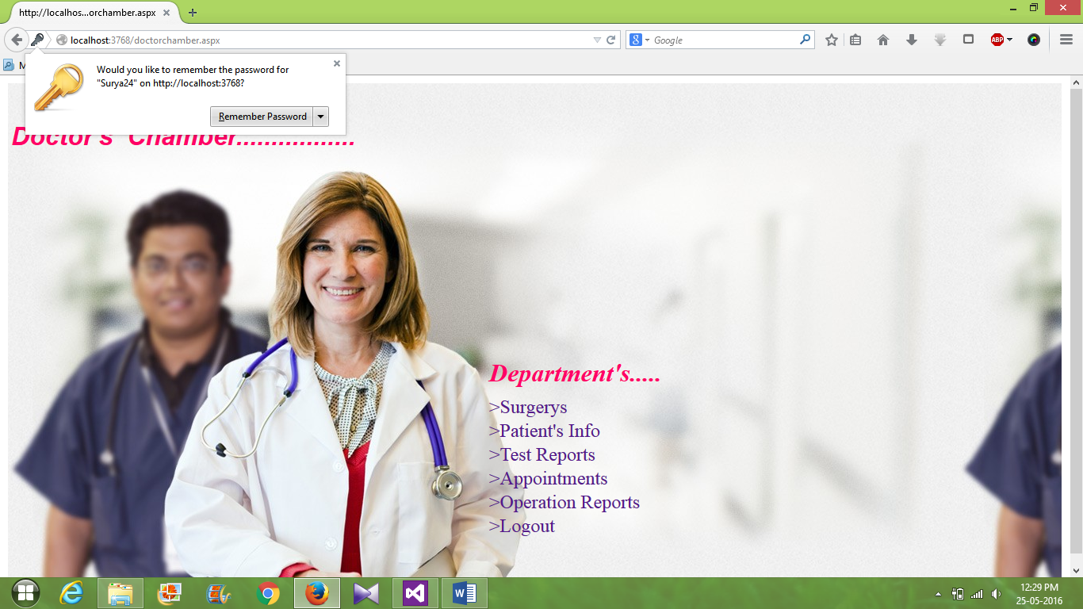

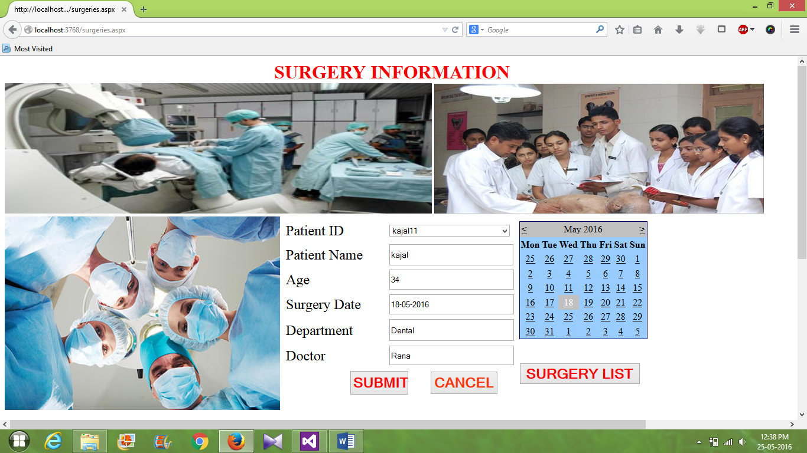

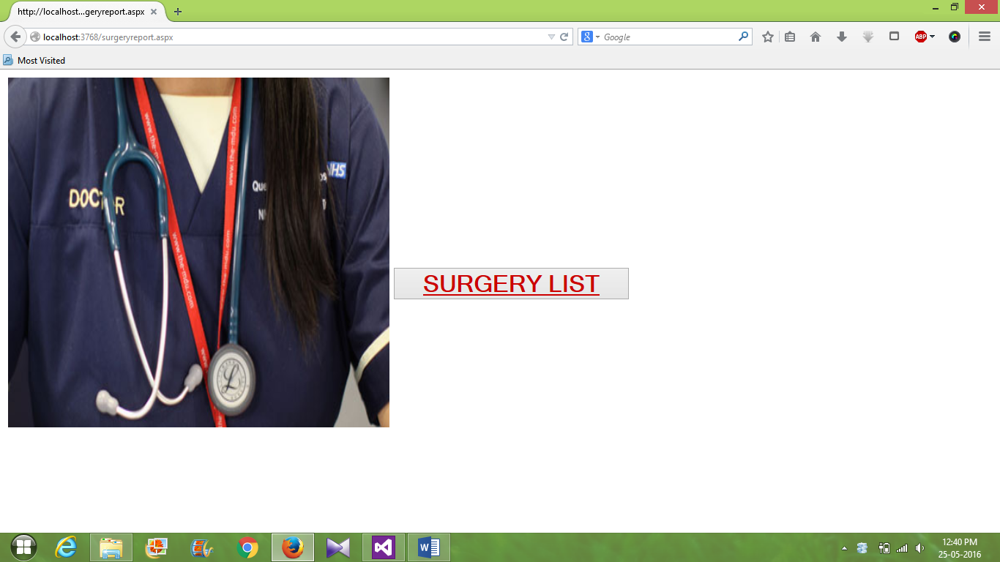

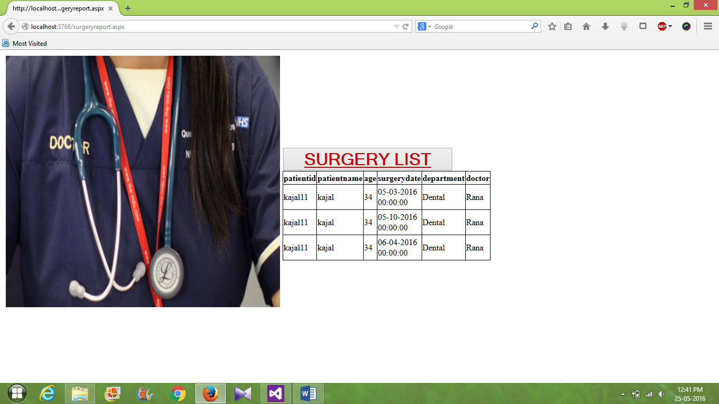

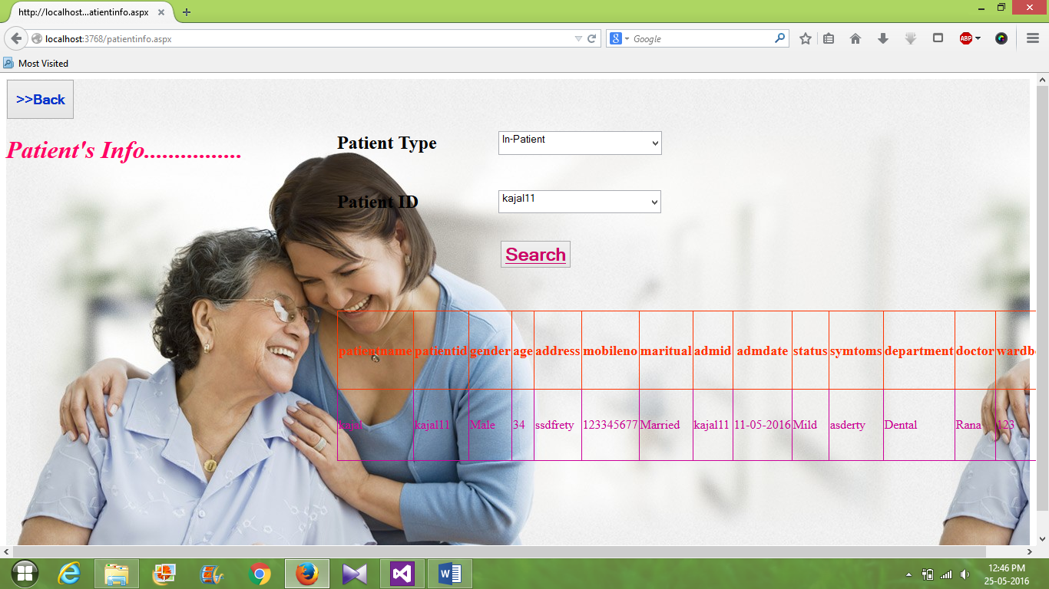

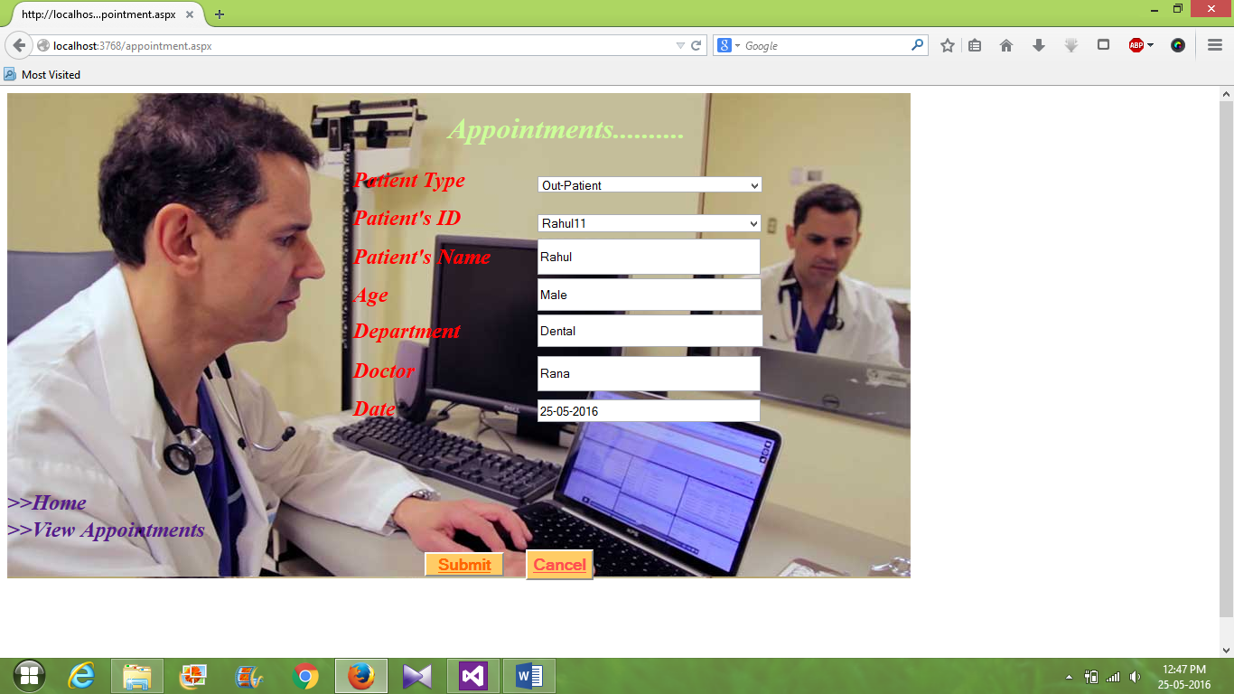

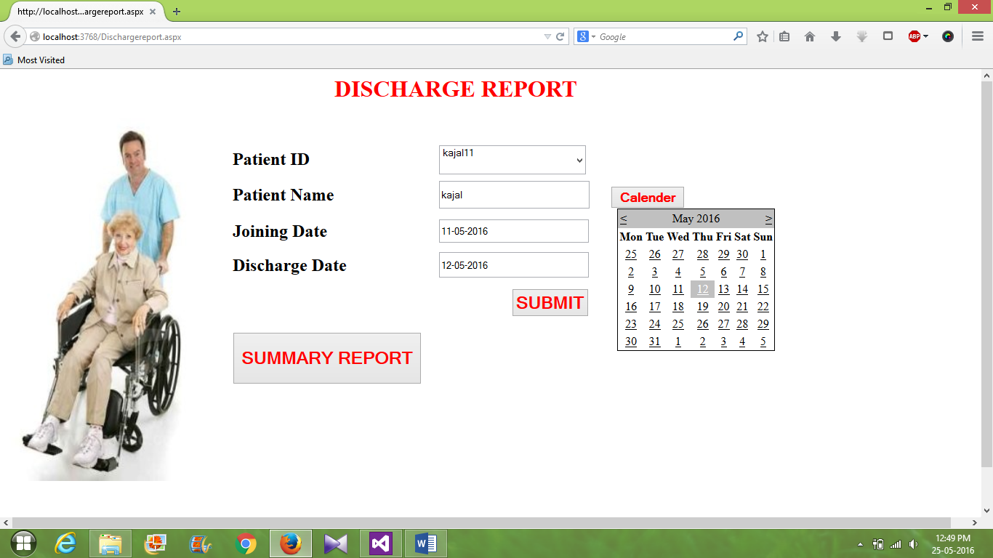

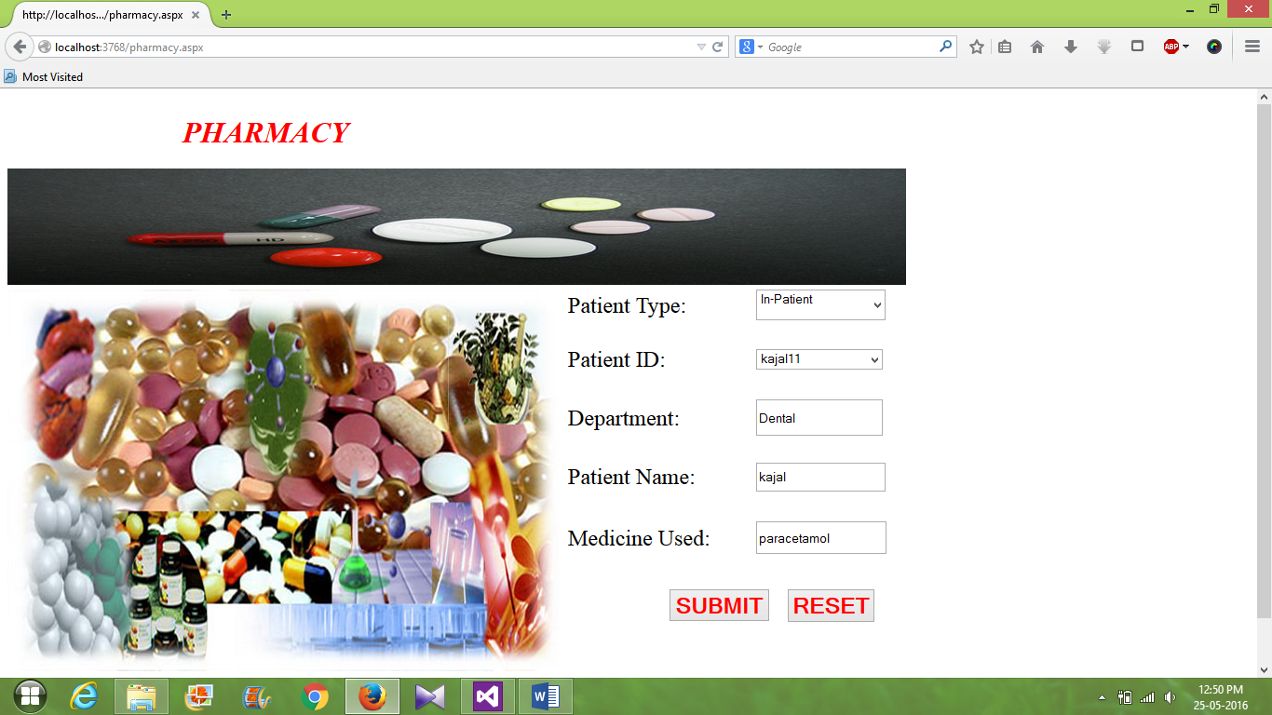

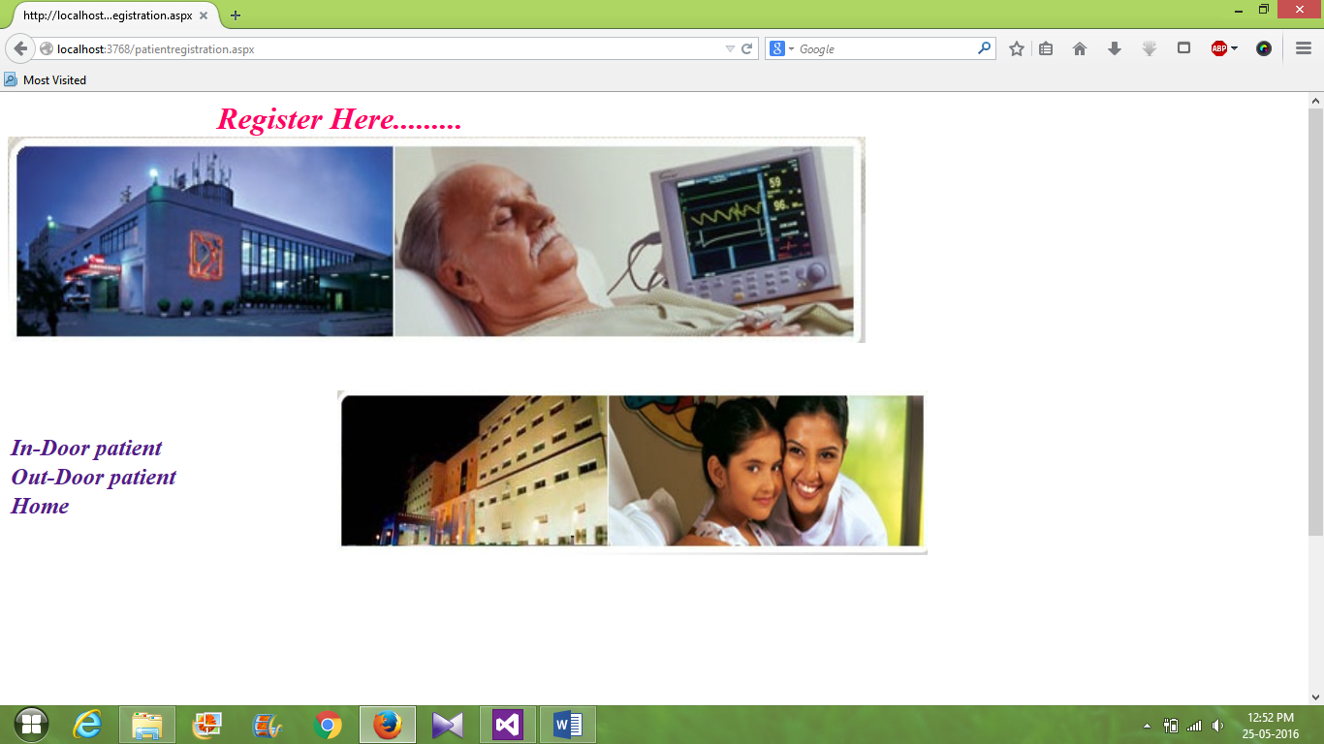

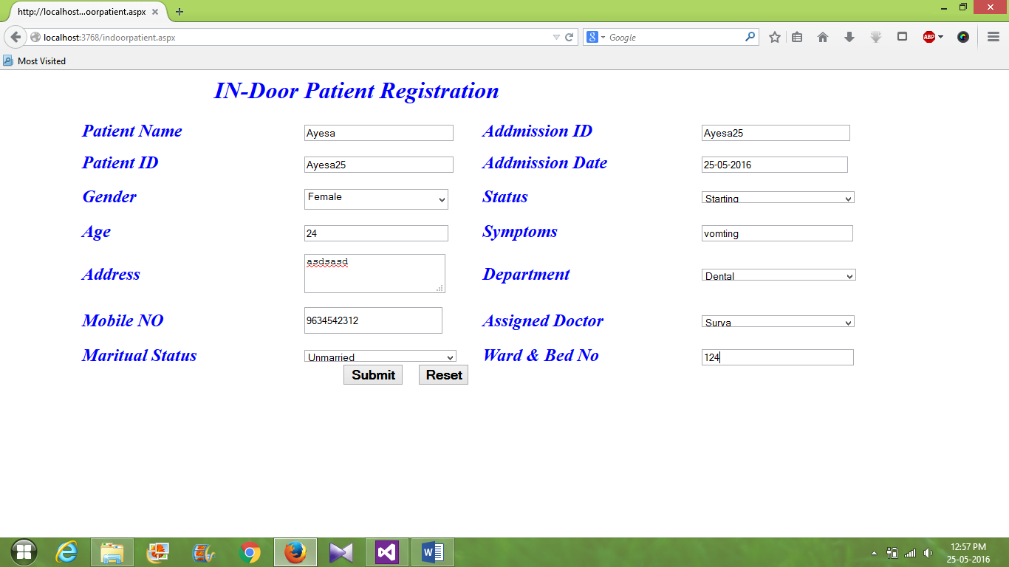

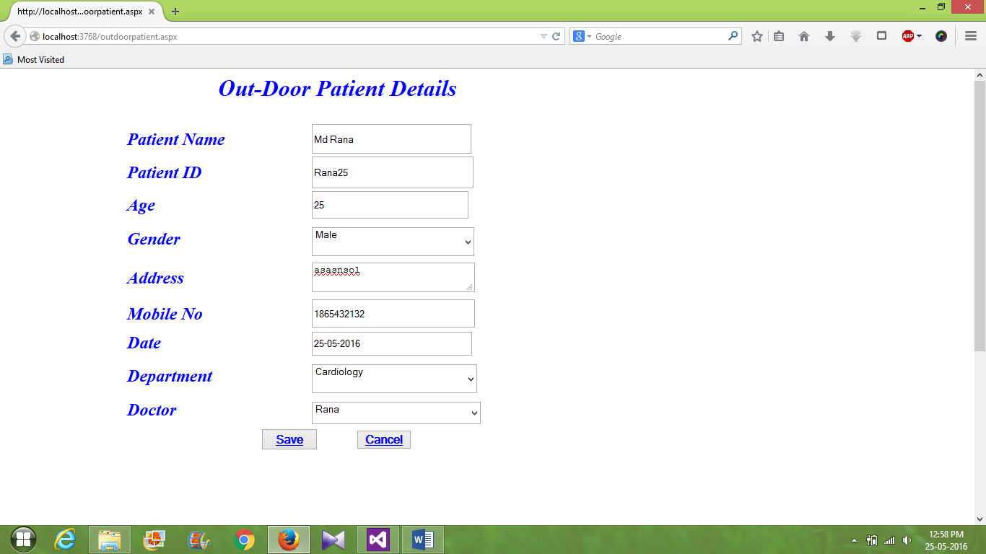

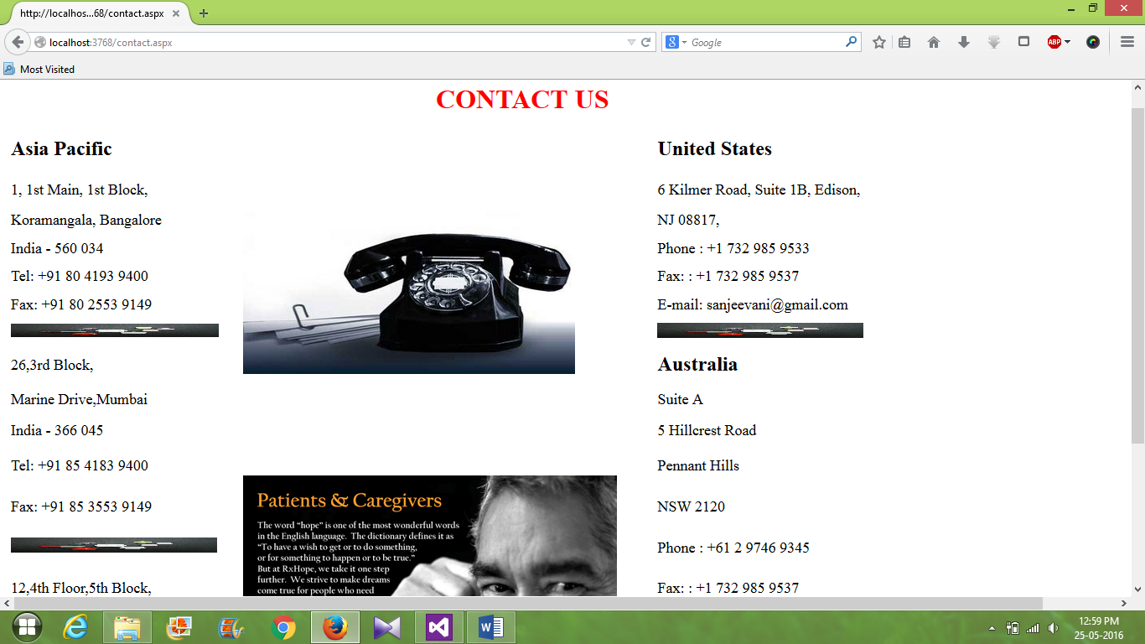



Conclusion & Future scope

**Thus from this project we have been able to use the applications of asp.net in creating a useful website for the online hospital management. There are many ways that this portal can be used and through this service not only can patients be treated and kept in record easily, but the huge population of young people can get jobs easily since they are quite acquainted with the working system of the software technology. Moreover this project makes the entire system time-saving and more efficient.**

**The website can be improved in future by introducing more detailed information of the doctors and patients (viz. Finger print sensors or face recognition sensors). Moreover this portal can be improved by increasing the security of the website , so that no information is leaked from it.**

BIBLIOGRAPHY

**As far as the information of this project is concerned , the vital source has been www.google.com . Apart from that many books like Software Engineering by Rajiv Mall have been helpful.**

**Thank You**

-----------XXXXXXXXXXX----------